**Experiment No: 06**

|  |  |  |  |
| --- | --- | --- | --- |
| **Roll No: 45** | **Name: Kartik A Parmar** | **Div: A** | **Batch: A-2** |

**Aim:** Social Network Analysis using R.

**Theory:**

**Social Network Analysis (Community Detection Algorithm)**

Social Network Analysis (SNA) is the process of exploring the social structure by

using graph theory. It is mainly used for measuring and analyzing the structural

properties of the network.

It helps to measure social network relationships (Facebook, Twitter likes comments

following etc..), Email connectivity, flows between groups, organizations, and

other connected entities.

Commonly used words in social network analysis.

A network is represented as a graph, which shows links (if any) between each

vertex (or node) and its neighbors.

Edge: – A-line indicating a link between vertices.

Component: – A group of vertices that are mutually reachable by following edges

on the graph.

Path: -The edges followed from one vertex to another are called a path.

**Community Detection Algorithm**

Communities are a property of many networks in which a particular network may

have multiple communities such that nodes inside a community are densely

connected.

Nodes in multiple communities can overlap. Think of your Facebook or Instagram

account and consider who you interact with daily. You might be heavily interacting

with your friends, colleagues, family members and a few other important people in

your life. They form a very dense community inside your social network.

**Why Community Detection?**

When analyzing different networks, it may be important to discover communities

inside them. Community detection techniques are useful for social media

algorithms to discover people with common interests and keep them tightly

connected. Community detection can be used in machine learning to detect groups

with similar properties and extract groups for various reasons. For example, this

technique can be used to discover manipulative groups inside a social network or a

stock market.

**Community Detection Techniques**

Community detection methods can be broadly categorized into two

types; Agglomerative Methods and Divisive Methods. In Agglomerative methods

(bottom up), edges are added one by one to a graph which only contains nodes.

Divisive methods(top down) follow the opposite of agglomerative methods. In

there, edges are removed one by one from a complete graph.

**R/igraph**

R/igraph is an R package of the igraph network analysis library.

**Directed Graph**

A directed graph (or digraph) is a set of nodes connected by edges, where the

edges have a direction associated with them.

**Hub and Authorities**

Basically, the hub has many outgoing links, and Authorities have many incoming

links. Hubs are defined as nodes with many edges or with edges that place them in

central positions for facilitating traffic over a network. The number of edges on a

node is called the node’s degree, and degree is the simplest and most commonly

used means of identifying hubs in graphs.

**Histogram of node degree**

**Code:**

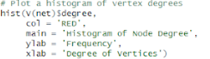

**Output:**

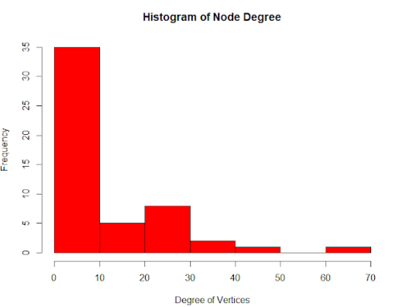

**Network diagram:**

**Code:**

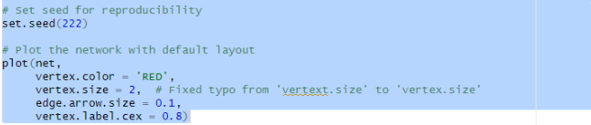

**Output:**

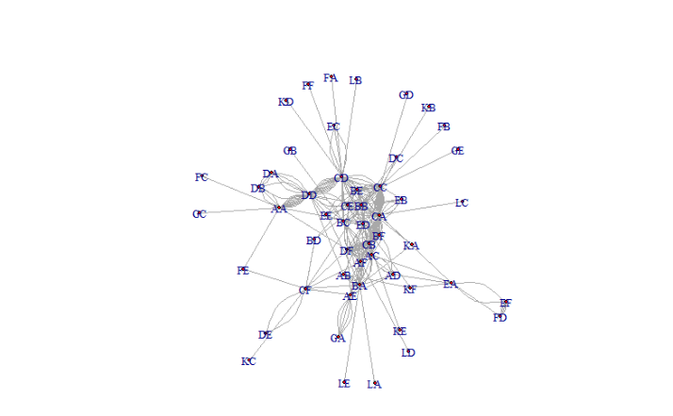

**Highlighting degrees and layouts**

**Code:**

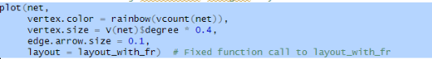

**Output:**

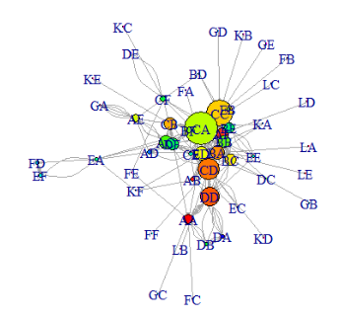

**Hub and Authorities**

**Code:**

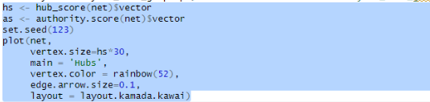

**Output:**

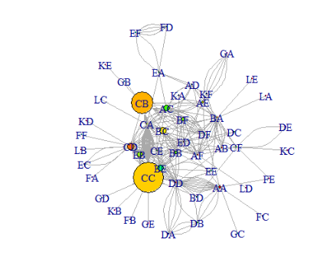

**Authorities**

**Code:**

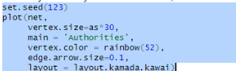

**Output:**

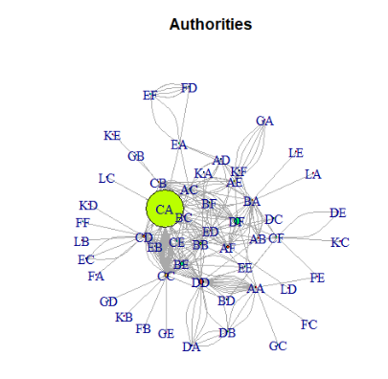

**Community detection**

**Code:**

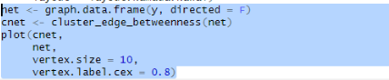

**Output:**

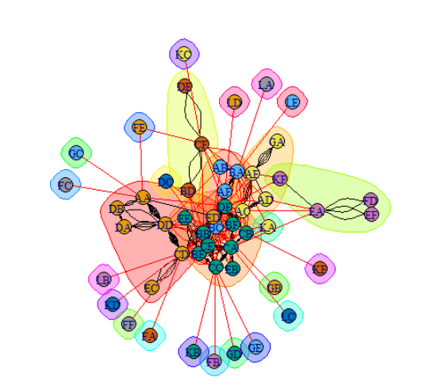

**Conclusion :** Hence we have successfully implemented Social Network Analysis using R.